📈 STOCK PORTFOLIO TRACKER & RESEARCH DASHBOARD
Welcome to the Stock Portfolio Tracker & Research Dashboard — a smart tool built with Python, Streamlit, and data visualization libraries to help users track their investments and research stock performance with ease.
This project was developed as part of my Python Full Stack Internship at CodeTechIT Solutions.

📌 Project Objective
To create a dynamic, interactive dashboard that allows users to:
- Track personal stock portfolios with real-time profit/loss analysis.
- View current prices and historical trends for any stock.
- Visualize performance and distributions using beautiful charts.
- Add or remove stocks directly from a user-friendly interface.

🚀 How It Works
This project has three core components:
🔧 Backend Logic (logic.py)
- Manages portfolio data using JSON-based persistence.
- Calculates real-time profit/loss, investment, and current values.
- Allows adding, removing, and fetching stock data using yfinance.
- Supports historical stock data lookup (1 year) for research.
🎨 Data Visualization (visuals.py)
- Uses matplotlib and seaborn for attractive, readable charts.
- Generates:
  - Closing price history
  - Volume trend over time
- Designed to save charts optionally for exports or reports.
🖥 Frontend Dashboard (dashboard.py)
- Built using Streamlit for web-based interaction.
- Supports:
  - Add, remove, and view portfolio
  - Research any stock's current price and price history
  - Displays charts inline
- Provides metric summary and data table views.

🧰 Technologies & Libraries Used
Tool / Library | Purpose
Python | Core programming language
yfinance | Real-time stock price and history data
matplotlib | Static plotting for line and volume charts
seaborn | Styled plots for closing and volume trends
Streamlit | Frontend UI and interaction
json & os | File handling for persistent portfolios

⚙️ Setting Up the Environment
1️⃣ Install Python 3.x
Download from: python.org/downloads
2️⃣ Install Required Libraries
pip install streamlit yfinance matplotlib seaborn
3️⃣ Run the App
streamlit run dashboard.py

✨ Features
- 📥 Add Stock – Quickly add stock with quantity and purchase price.
- ❌ Remove Stock – Cleanly delete stocks from portfolio.
- 📊 View Portfolio – Full summary with total investment, current value, and returns.
- 🔍 Research Stock – Lookup live prices and price history of any ticker.
- 📈 Price & Volume Charts – Yearly trend visualizations.
- 💾 Persistent Storage – Portfolio saved locally in portfolio.json.
- 🌐 Web Interface – No terminal interaction needed.

🧾 Sample Screens
- 📁 Portfolio Overview
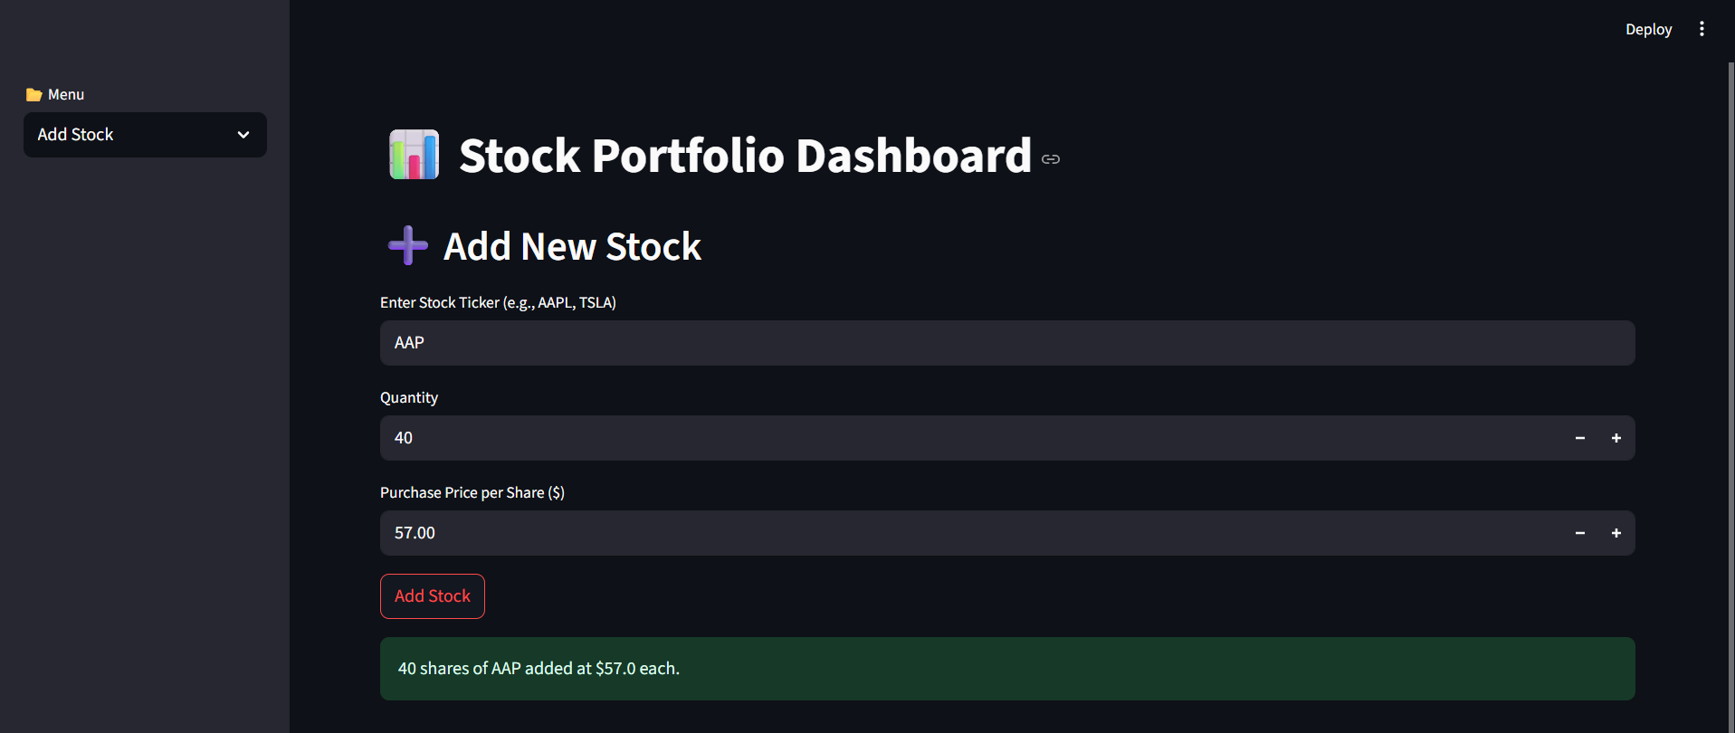
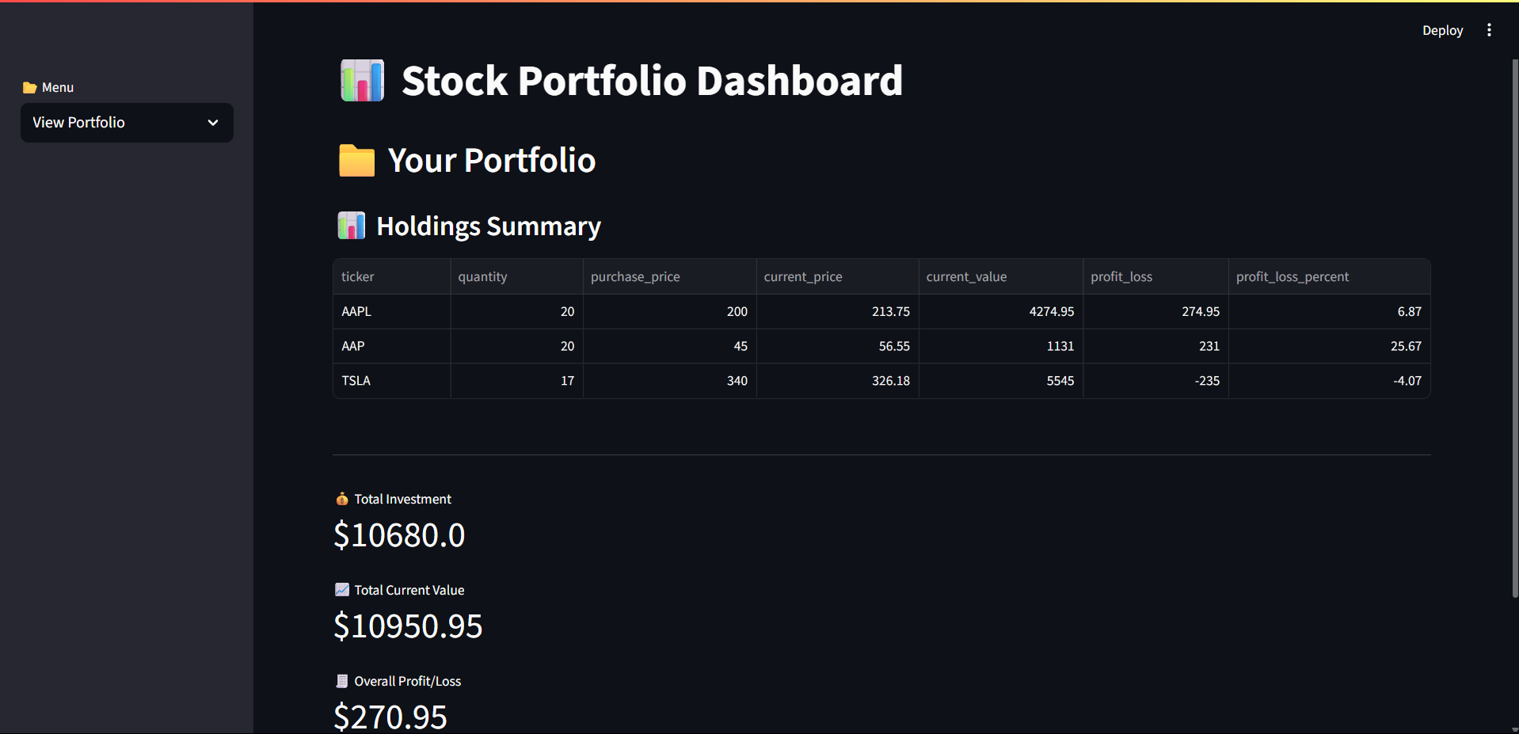
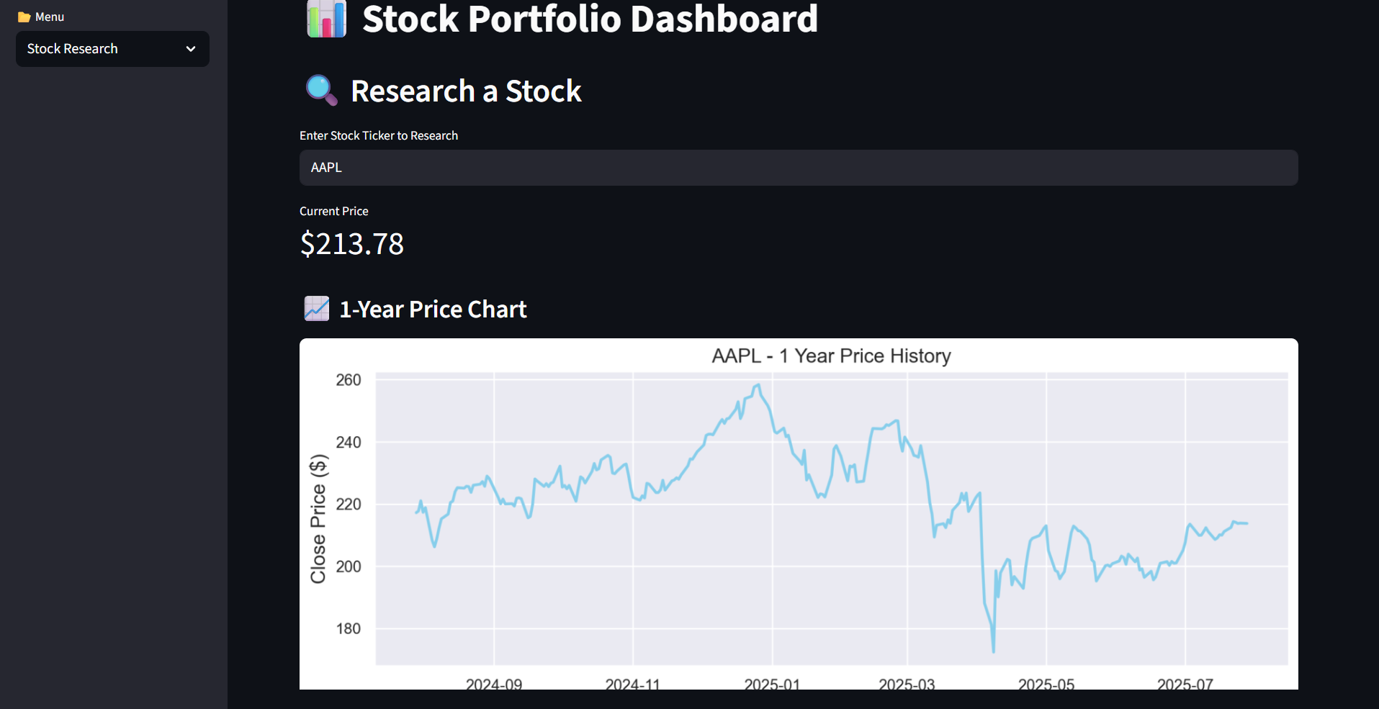

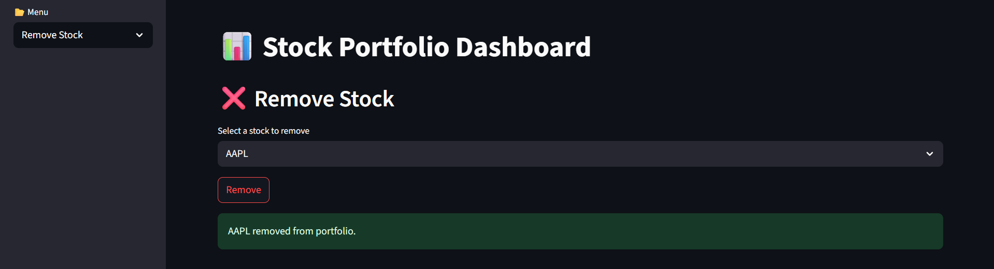

🧑‍💻 Author
Krishna
Project created during internship at CodeTechIT Solutions.

